5. 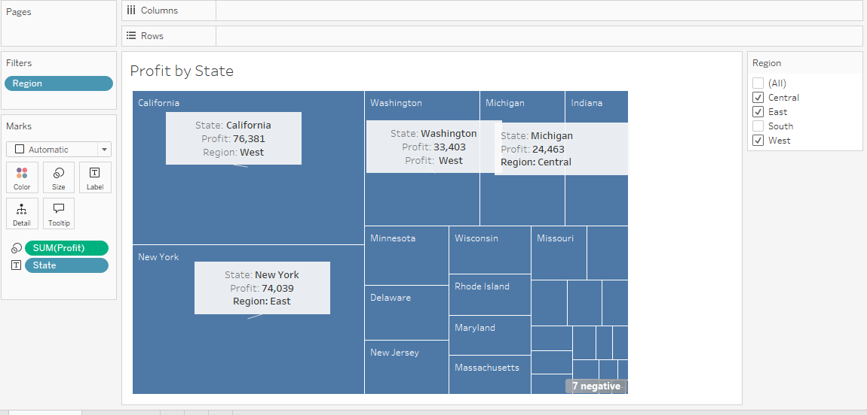

7.

8. 

